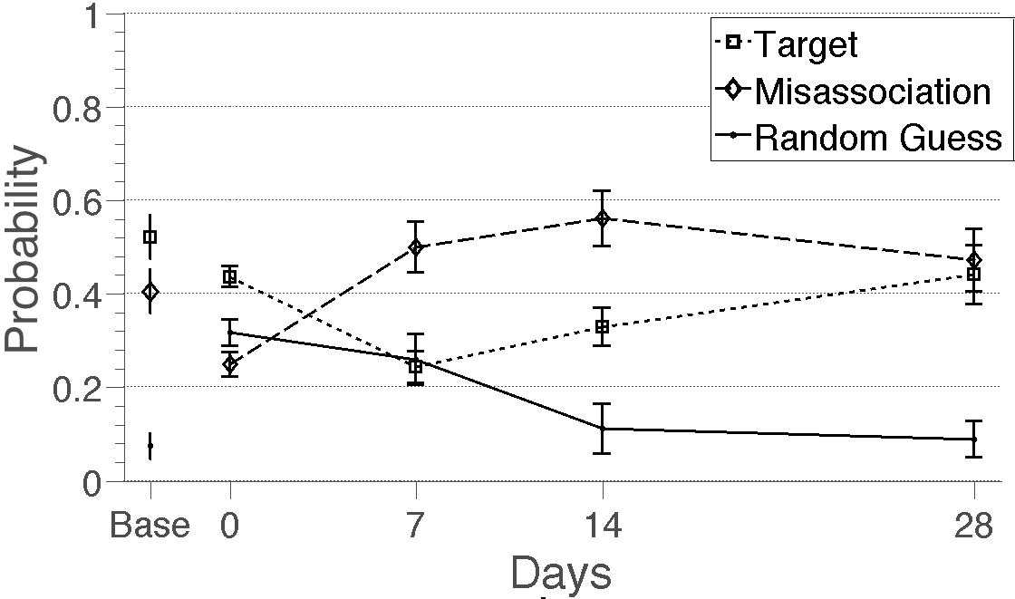
A
C
B
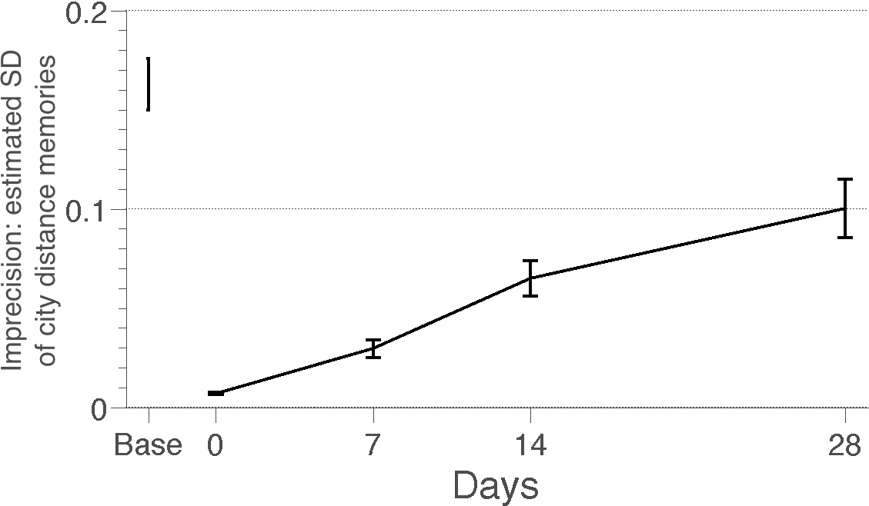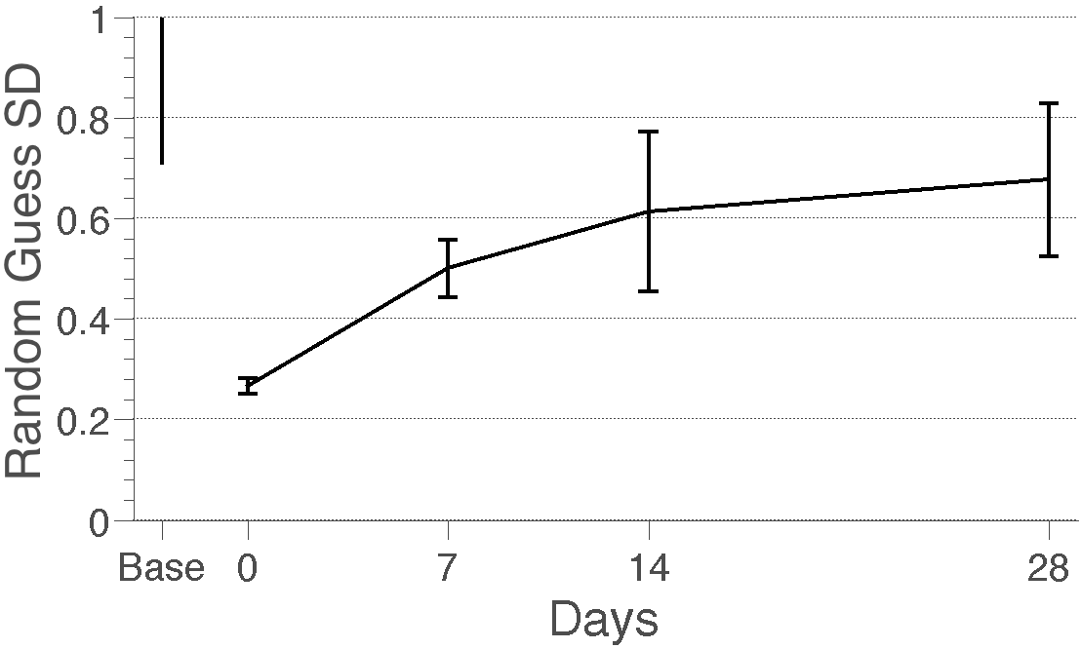
Figure 10. Estimated noise, misassociation and random guessing for Experiment 4. (A) Estimated probability of selecting the target (dotted lines and squares), making a misassociation (dashed lines and diamonds) and randomly guessing (solid lines and dots). (B) The standard deviation (SD) of recalled facts. (C) The standard deviation of random guesses around the mean distance. In these graphs, the first block of training acts as baseline performance (Base). The continuous lines indicate performance during the four testing blocks. During forgetting, subjects remembered many distances precisely but associated them to the wrong city pairs. Error bars indicate posterior SD.

